AI2168

GSM/ GPRS/ GPS Tracker

Ver 1.0

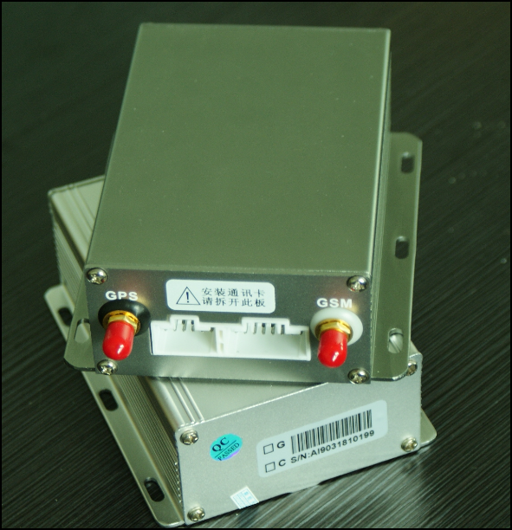

Introduction

AI2168 is professional vehicle tracker, which suitable for even industrial vehicle like Fuel truck, taxi, bus etc.

Major Functions

Categories | Function | Details
Live  Fleet Management | Live Tracking | Monitor vehicle location on LIVE with Udrivetec WEBGPS fleet management center system.
Live  Fleet Management | Track according interval | Tracker sends currently position and status information to fleet management center as per set interval, shortest interval up to 5 seconds.
Live  Fleet Management | Multiple Geo-fence Area | Tracker can be set with more than 30 different Geo-fence areas , 5~50 vertexes. Detect real time position and status information when vehicle is driven into/out of geo-fence area area.
Live  Fleet Management | Speeding report | Monitor vehicle’s speed real time, send over speed alarm to fleet management center when over speed.
Live  Fleet Management | Mileage | Calculate mileage and report by using of GPS speed or external speed sensor.
Live  Fleet Management | Fuel Monitor (Optional) | Detect fuel tank level, raise alert while fuel decrease or increase abnormally. Avoid leakage and fuel being stolen. The function suitable for fuel shipping vehicle or shipping company.
Live  Fleet Management | SMS tracking | Simply text to tracker request position. Tracker will check the cordinate in google map and reply location Address.
Alert & Warning | SOS Request | Driver hold the alarm button in emergency, tracker will report emergency alarm information to fleet management center and controller phone.
Alert & Warning | External Power cut off report | When Tracker’s power is cut off, tracker will report alarm to fleet management center. (Need additional battery)
Alert & Warning | Remote listening | Controller phone could call in and get the voice on tracker site, without interrupt the driver. Device will auto hang on call after
Alert & Warning | Immobility Vehicle | While vehicle being rob or stolen, user could immobize the vehicle.
Communication | Double fleet management Center | Send message to two server.
Communication | UDP/TCP Connection | Tracker supports various communication method, either SMS or GPRS (TCP / UDP). Accordance with the actual situation, Tracker can be set with both the main mode and supplement mode, or only a single mode of communication.
Communication | Support DNS Analyse | Tracker can be set to monitor domain name. Tracker resolves IP address as per domain name and build TCP connection.
Communication | Parameter set | All parameters of Tracker can be set or changed by sending order from fleet management center via GPRS.
Communication | Tracker control | Fleet management center can send order to control Tracker’s status, like switch On/Off, restart, factory setting etc.
Communication | Set parameter via cell phone | Any cell phone can be used to edit special short message to setup basic parameters, for example like center service, APN, server’s IP address, port number, domain name, controller number.
Power Management | Intellectual Power Control | Tracker can identify battery pressure automatically and keep working for either 12V or 24V battery.
Power Management | Power Saving Mode | While engine off, device automatically switch off GPS and GPRS connection, extend more battery life
Power Management | Low Voltage Protect | When car battery voltage lower than a specific value, tracker will be switch off so as to avoid damage to battery because of over consummation.。
Software  Update | Firmware Upgrade | Newest firmware can be upgrade through GPRS or internal port
Self protection | Machine self detection | Tracker will detect whether all main components works, and report the malfunction information to driver when something abnormal happens, for repair and maintains convenience.
Self protection | GPS antenna fleet management (Optional) | Device check GPS antenna open circuit or short circuit etc. This will be available to avoid inaccurate positioning caused by damage of GPS antenna.
Camera  (Optional) | Real time snapshot | Take picture by simply click button on the system, tracker send the picture by GPRS
Camera  (Optional) | Timing snapshot | Tracker can take snapshot as per set interval
Camera  (Optional) | Emergency automatic snapshot | When there is emergency alarm, Tracker will take snapshot as per set interval and times
Camera  (Optional) | Snapshot if status change | When vehicle status changes (ACC on/off, vehicle door open/closed, empty/loaded vehicle), Tracker will take snapshot as per set interval and times.

Installation

Note: below diagram is for installation techinician reference only. Actual installation must be performed with direction of professional person authorized by manufacturer, or manufacturer will not take any result caused by incorrect installation.

- Main device front panel：
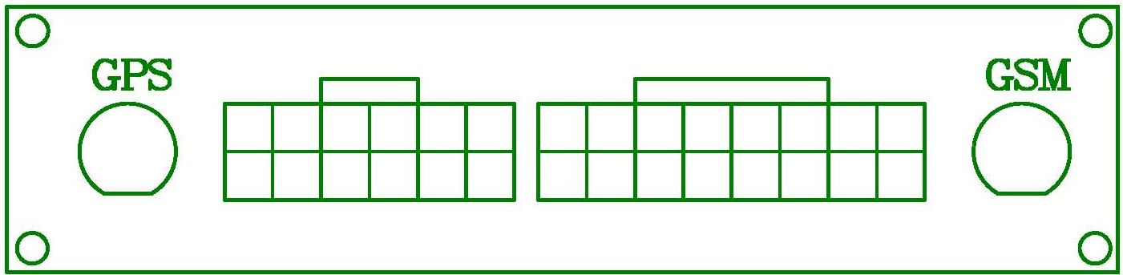
GSM antenna

Expandable Function Port
(12 PIN)

4 fixing bolt
GPS antenna
LED

Core Function Port
(16 connector)

2. Screw off 4 bolt 3. Take out PCB board.

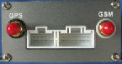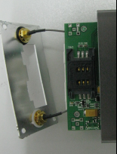

4. Insert SIM card as picture below 5. Lock SIM card into slot.
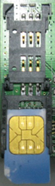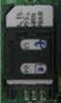

Cable for Core Function Port

  - Main power supply wire：
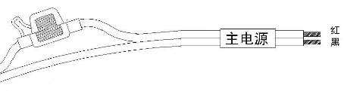

Red
Black
Power
Positive (red) and negative (black) pole of main power supply wire connect to positive and negative pole of battery.

  - Ignition detect wire：
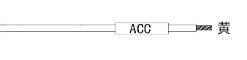
Yellow
Ignition detect wire connects vehicle’s ACC ignition signal.

  - Relay Cut off wire (For immobilize vehicle)：
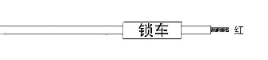

Relay
RED
Use with Relay, connection as below

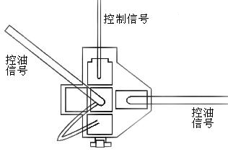

RED wire from tracker
+12v
Cut Off

  - Data wire：
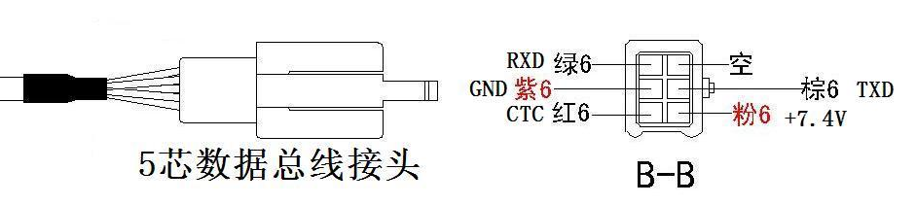
5 Pin Connector
Data wire use to connect LCD or Handheld, which not included in standard parckage

  - Hand free/monitor microphone:
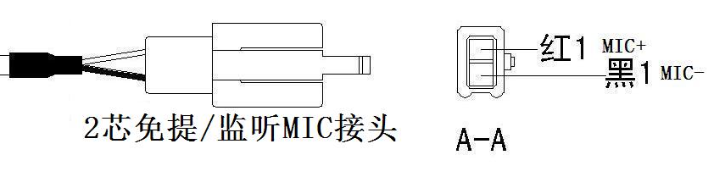
2 Pin connector

F．SOS button:

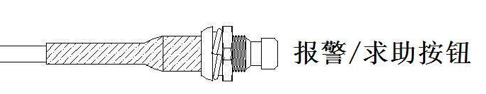
Emergency Help Request

Quick Start Guideline

Device Setup:

I) Connect ACC and power cable, switch on power supply. Make sure SIM card putted in properly.
II) Check status LED. Make sure device successful power on

LED | Description
Shinning 3 seconds once | Device working
LED off | No power in or ACC not connected.
Shinning 0.2 seconds once | Data start transmission

III) Use SMS command below to tracker :

Command: (4U,Controller Mobile number, 220165009225,12342332,APN,,SIM/UIM, ,1, User Password)

Sample: (4U,,220165009225,12342332,tmobile,,13312926705,,1,APNUSER 123456)

Description:
Controller Mobile Number: The phone number which use to send the SMS
APN : Access Point Name, consult mobile service provider for User name and password
SIM/UIM : The Phone Number for the SIM card in tracker

The device will reply "Done!" while setup success.

On-line Fleet Management System Setup

I) Log in to http://webgpsonline.com

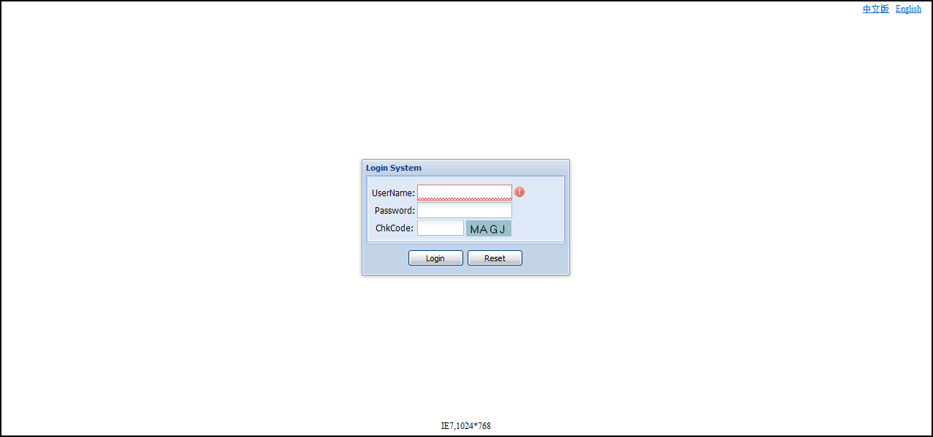

ii) Click on "Live Tracking", confirm your account group being create. In this example, Benny is the group account.

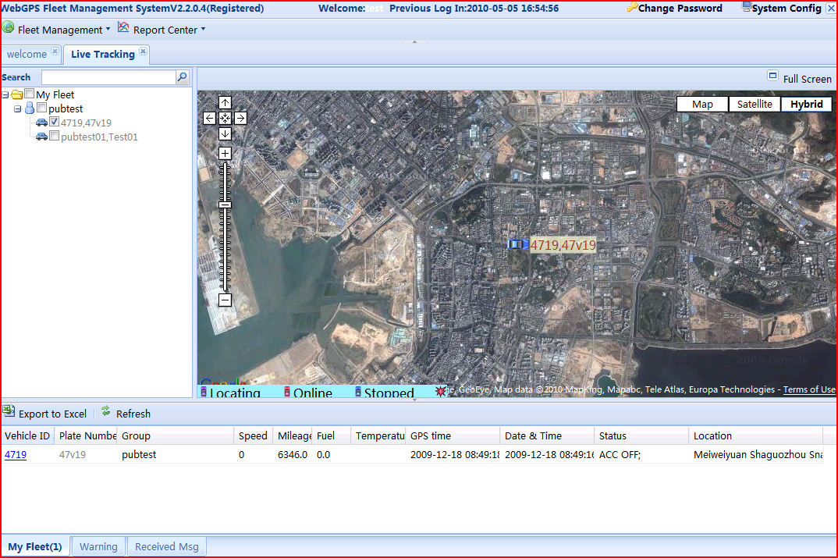
1

iii) Vehicle management

1. Click on "Vehicle Manager"
2. Click "Add" for register a new device.

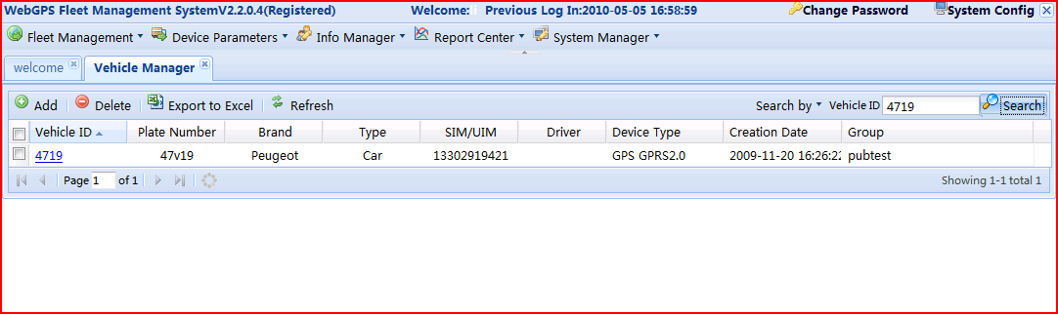
1
2

Iv) Input necessary info into column, after that click save. Compulsory fill in the item with "*" icon.

- Vehicle ID: Internal Identification Code or description for the installed vehicle
- Plate No: Plate number
- Type: Select Protocol for your device. UDT series select "PGPS myGPS", AI2168 Series choose "AiGPS GPRS2.0"
- No: The ID for the SIM card putted into device (Most SIM ID same as the SIM card phone number)
- SIM/UIM: SIM card phone number (Very Important)

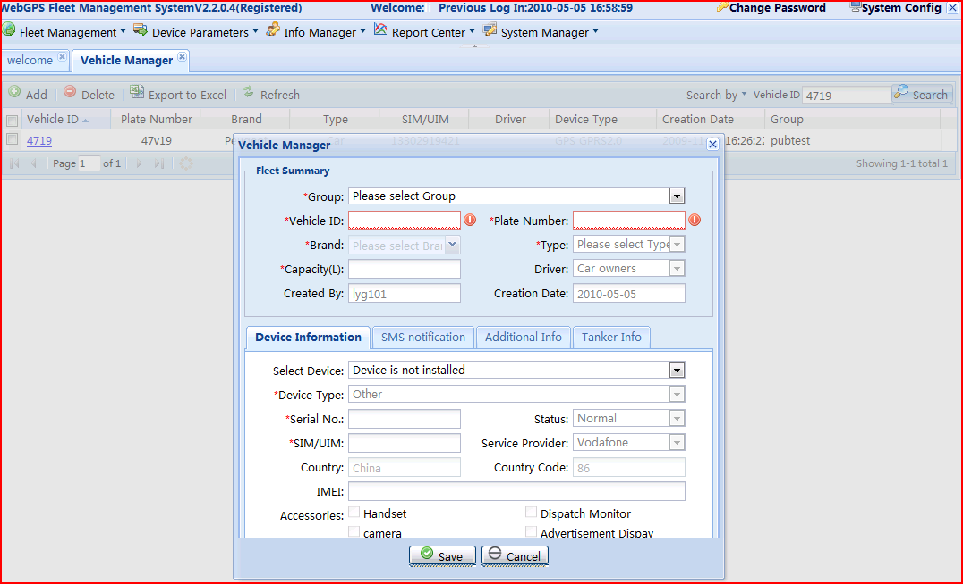

V) Setup Account Manager

- Click On Account Manager (under System Manager)
2. Click on your login account. Use "Benny" in the example.

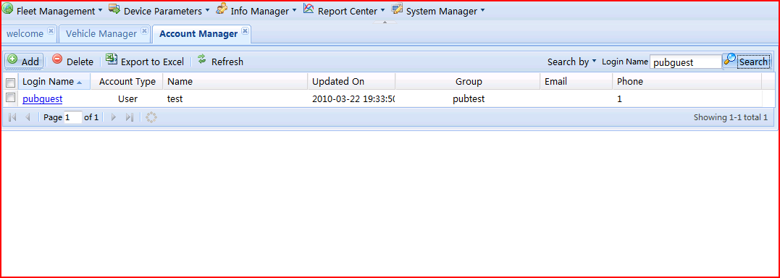
1
2

Vi) Fill in Info

- Choose the time zone in your area
- Click on "Their Role", tick off "All right role" 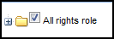
- Click Monitoring Vehicle, tick off "All vehicles" 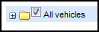
- Save the setting
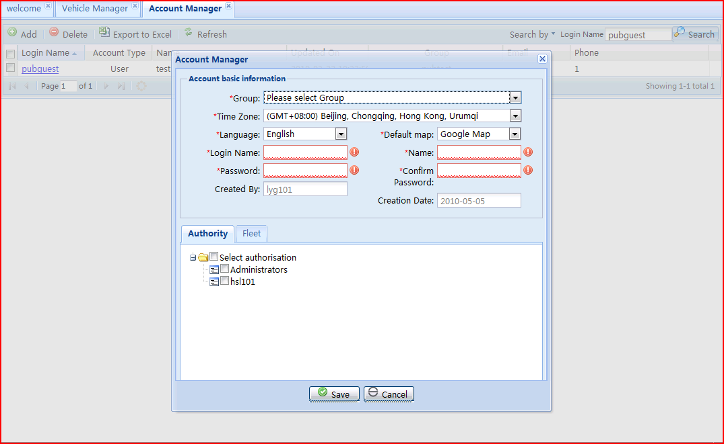
1
2
3
4

SMS command:

- Request Location

Command: (AI*PPassword)
Sample: (AI*P111111)

Description:
Default Password as 111111. The tracker will take location address in goggle map and reply to sender phone.

- Change Password

Command: (AI*WOld Password*New Password)
Sample: (AI*W111111*123456)

Description:
On the sample message, device change password from 111111 to 123456

Technical Specification

Hardware
GSM module | Huawei GTM900, GSM 850/900/1800/1900, Support dual-band or quad-band
GPS Chipset | SIRF-Star III chipset
GPS Sensitivity | -159dBm
GPS Frequency | L1,1575.42MHz
C/A Code | 1.023MHz chip rate
Channels | 20 channel all-in-view tracking
Position Accuracy | 10 meters, 2D RMS
Velocity Accuracy | 0.1 m/s
Time Accuracy | 1 us synchronized to GPS time
Datum | WGS-84
Reacquisition | 0.1 sec.,average
Hot start | 1 sec.,average
Warm start | 38sec.,average
Cold start | 42sec.,average
Altitude Limit | 18,000 meters (60,000feet) max.
Velocity Limit | 515 meters/second (1000knots) max.
Acceleration Limit | Less than 4g
Jerk Limit | 20m/sec
Operating temperature | -25℃ to 70℃
Humidity | 5% to 95% Non-condensing
Dimension | 95mm*46mm*18mm
Voltage | Rechargeable 1100 mAh battery(3.7V)
Charging connector | DC 5V

1 | Application scope | Applicable for positioning and fleet management for vehicle/
2 | Operation condition | Relative temperature | -20℃～+80℃
2 | Operation condition | Relative humidity | ≤90%
2 | Operation condition | Atmospheric pressure | 86～106KPa
2 | Operation condition | Power supply voltage | Direct current 10—36V（applicable for vehicle with 12V/24V storage battery）
3 | External dimension and weight | External dimension
3 | External dimension and weight | Main device | 112mm×88mm×38mm
3 | External dimension and weight | Product weight
3 | External dimension and weight | Main device | 0.3kg

